

An **Everyday EI** Quick Tip is a concise, easy to understand piece of information designed to enhance knowledge and application of Emotional Intelligence (EI) in daily activities.The tips are designed to reinforce key EI skills and behaviours with practical actions individuals can integrate into their daily routines.

**Everyday EI** tips highlight “pearls of experience” for applying EI in home-based palliative care.

You can use the following tips in your team communications, emails and newsletters . (These tips are also available in graphic images on the SPRINT Hub).

**Did you know… Building strong relationships with patients can improve their quality of life.**

Research shows that patients who feel emotionally supported by their healthcare providers report a 20% increase in life satisfaction.

**Did you know… Effective communication in palliative care can reduce patients’ anxiety and depression.** Studies indicate that clear and compassionate communication can reduce patient anxiety by 30%.

**Did you know… Creating bonds with patients can lead to better pain management.**

Patients with a strong rapport with their healthcare providers are more likely to communicate their pain levels accurately, leading to more effective pain management.

**Did you know… Healthcare providers who practice active listening are 50% more likely to understand patients' needs and concerns.** Active listening fosters trust and open communication.

**Did you know… Involving family members in care decisions can improve patient outcomes.**

When family voices are valued, patients often experience a 15% improvement in emotional well-being.

**Did you know… Regular team meetings among healthcare providers can enhance the delivery of palliative care.** Teams communicating regularly about patient care are 35% more efficient and cohesive.

**Did you know… Patients who participate in decision-making about their care report higher satisfaction levels.** Shared decision-making can improve patient satisfaction by 20%.

**Did you know… EI can enhance teamwork in palliative care settings.** Teams with high EI members report a 25% increase in collaborative problem-solving and efficiency.

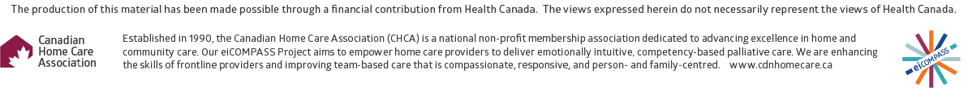

**Did you know… Healthcare providers with strong relationship-building skills are more likely to experience job satisfaction.** Providers who develop meaningful connections with patients and colleagues report a 30% increase in job fulfilment.